RAMSAY SCHOOL

School Board Principal’s Report March 2026
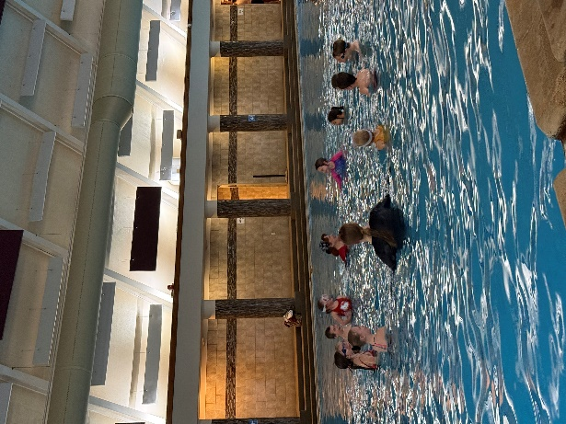
Ramsay Kindergarten class at Fairmont!!

Enrollment as of March 18, 2026
Kindergarten: 12
First Grade: 12
Second Grade: 21
Third Grade: 22
Fourth Grade: 20
Fifth Grade: 29
Sixth Grade: 12
Seventh Grade: 14
Eighth Grade: 8

TOTAL: 150

UPDATES:
- Pre-K teaching position/policies

- MAST Testing

- Homework Opportunity
- Animal Wonders

- Emergency Closure Day

- Swimming

- Academic Olympics

- Fire Drill with a blocked exit

- Readwell Curriculum

- Building Committee Meeting on March 23rd at 2:00

- School Calendar

COMING EVENTS:
- RBHI

- Hope Squad

- Dougie Hall

- Rotary Club

- Spring Professional Development – April 15th - YMHFA

- Counselor

- Next meeting: April 11th?

