RAMSAY SCHOOL

School Board Principal’s Report December 2025
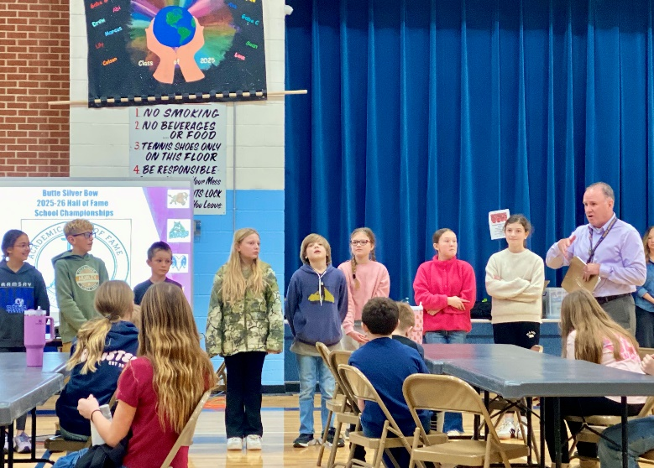
Ramsay School Hall of Fame Winners!!
Enrollment as of December 10, 2025
Kindergarten: 12
First Grade: 13
Second Grade: 21
Third Grade: 21
Fourth Grade: 20
Fifth Grade: 29
Sixth Grade: 11
Seventh Grade: 16
Eighth Grade: 8

TOTAL: 151

UPDATES:
- Pre-K funding

- Hope Squad

- Bus Driver

- MAST Testing

- Christmas Program

- Wind Damage

COMING EVENTS:
- Counselor

- Next meeting: February 11th?

