RAMSAY SCHOOL

School Board Principal’s Report May 2025
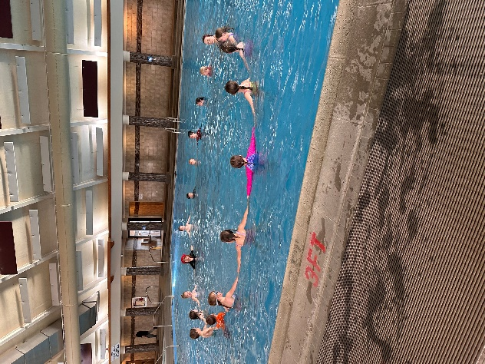
Kindergarten swimming at Fairmont!!
Enrollment as of May 14, 2025
Kindergarten: 15
First Grade: 19
Second Grade: 20
Third Grade: 21
Fourth Grade: 26
Fifth Grade: 12
Sixth Grade: 25
Seventh Grade: 7
Eighth Grade: 12
Resource: 1

TOTAL: 160

UPDATES:
- Ramsay Park / Butte Parks and Rec

- SPED Teacher/Counselor/Art Teacher/Music/Paraprofessionals/Cooks/Bus Monitors

- Civil Rights Data Collection completed

- Accreditation – May 19th

- Ripple – April 10th

- Spring Professional Development – April 11th

- Draw the Line/Respect the Line (6th – 8th) – April 28th

- Hall of Fame – May 1st

- City Track Meet May 7th

- SBAC Testing (4th Round) – May 5th – May 23rd

COMING EVENTS:
- Swimming ends May 19th

- Fieldtrips / Color War

- 8th Grade Yellowstone Fieldtrip – May 20th – May 22nd

- Howard/Donna/Stacy S. – Plaque

- Next meeting: June 11th?

