RAMSAY SCHOOL

School Board Principal’s Report June 2025
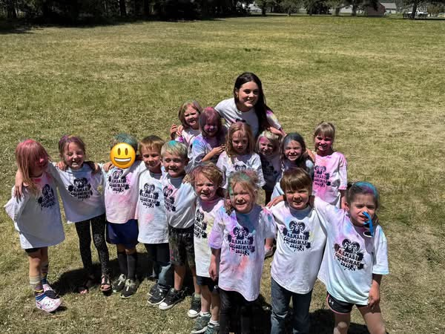
Kindergarten after the Color War!!
Enrollment as of June 18, 2025
Kindergarten: 15
First Grade: 19
Second Grade: 20
Third Grade: 21
Fourth Grade: 26
Fifth Grade: 12
Sixth Grade: 25
Seventh Grade: 7
Eighth Grade: 12
Resource: 1

TOTAL: 160

UPDATES:
- Ramsay Park / Butte Parks and Rec

- SPED Teacher/Counselor/Art Teacher/Music/Paraprofessionals/Cooks/Bus Monitors

- Fieldtrips / Color War

- 8th Grade Yellowstone Fieldtrip – May 20th – May 22nd

- End-of-the-year Award Ceremony and Retirement Celebration – June 9th

- Howard/Donna/Stacy S. – Plaques

- 8th Grade Graduation – June 10th

- PIE Field Day – June 11th

- PIR – Record Keeping Day – June 12th

- SBAC Testing (4th Round) – May 5th – May 23rd

- Marsh McLennan Insurance Inspection Report

- Fire Safety Inspection

- McKinstry

COMING EVENTS:
- Paraprofessional Position

- Next meeting: July 9th?

