RAMSAY SCHOOL

School Board Principal’s Report July 2025
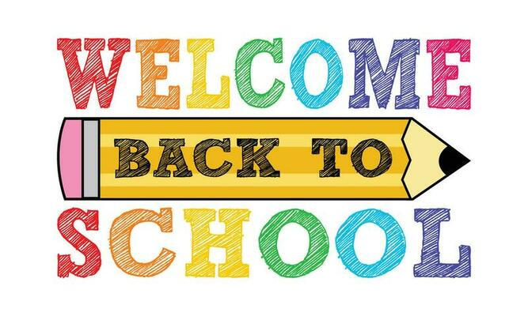
Enrollment as of August 13, 2025
Kindergarten: 14
First Grade: 13
Second Grade: 19
Third Grade: 20
Fourth Grade: 17
Fifth Grade: 25
Sixth Grade: 13
Seventh Grade: 17
Eighth Grade: 8
Resource: 1

TOTAL: 147

UPDATES:
- Ramsay Park - Trees

- School cleaned!

- McKinstry

- 2025-2026 Class Schedules

COMING EVENTS:
- Fall PIR – August 22nd and 25th

- School Starts August 26th!!

- Paraprofessional Position

- School Psychologist Contract

- Speech

- SBAC Testing

- SPED – in classrooms

- Shop/Music/Art – Sept 15th

- August PIR – Bret Brooks – Aug 22nd

- Next meeting: August 13th?

