**RAMSAY SCHOOL**

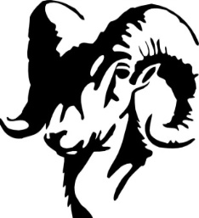

**School Board Principal’s Report March 2025**

**Enrollment as of March 18, 2025**

Kindergarten: 16

First Grade: 19

Second Grade: 21

Third Grade: 21

Fourth Grade: 26

Fifth Grade: 13

Sixth Grade: 25

Seventh Grade: 7

Eighth Grade: 12

Resource: 1

**TOTAL: 161**

**UPDATES:**

* Ramsay Park / Butte Parks and Rec
* SPED Teacher
* 2025-2026 Calendar
* Girls’ Basketball – 2 teams
* Fire Drill with a blocked exit – February 19th
* County Spelling Bee – February 20th at East
* Battle of the Books (Ramsay) – March 6th
* Battle of the Books (Missoula) – March 11th
* Academic Olympics – March 18th
* Downhill Skiing (5th – 8th) – March 19th
* Dept. of Labor and Industry Safety Inspection
* Homework Opportunity
* Butte Education Foundation Grant

**COMING EVENTS:**

* SBAC Testing (3rd Round) – April 1st
* Resident Artist – March 26th and 27th
* State Science Fair (Missoula) March 31st
* Swimming – April 7th
* Spring Professional Development – April 11th
* Music/Piano – April 22nd
* 8th Grade Yellowstone Fieldtrip – May 20th – May 22nd
* School Counselor
* Howard – Plaque
* Replacement of the Mods/Contractors/Contractor Guidelines
* Next meeting: April 9th?