**RAMSAY SCHOOL**

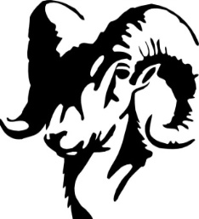

**School Board Principal’s Report February 2025**

**2025 Ramsay Spelling Bee Competitors**

**Enrollment as of February 12, 2025**

Kindergarten: 16

First Grade: 19

Second Grade: 21

Third Grade: 20

Fourth Grade: 26

Fifth Grade: 12

Sixth Grade: 25

Seventh Grade: 7

Eighth Grade: 12

Resource: 1

**TOTAL: 159**

**UPDATES:**

* Ramsay Park / Butte Parks and Rec
* CRISS Training
* SPED Teacher
* Boys’ Basketball
* Girls’ Basketball – 2 teams
* Ramsay Spelling Bee – February 5th
* Downhill Skiing
* Cross Country Skiing
* SBAC Testing (2nd Round)
* Cooks
* Dept. of Labor and Industry Safety Inspection
* Homework Opportunity
* Student Suspension
* Butte Education Foundation Grant
* 2025-2026 Calendar Options

**COMING EVENTS:**

* Fire Drill with a blocked exit – February 19th
* County Spelling Bee – February 20th at East
* Swimming – March 3rd
* Science Fair – March 4th (Missoula – March)
* Resident Artist – March 26th and 27th
* Battle of the Books – March 6th
* Academic Olympics – March 18th
* Spring Professional Development – April 11th
* Music/Piano – April 22nd
* School Counselor
* Howard – Plaque
* Replacement of the Mods/Contractors/Contractor Guidelines
* Next meeting: March 12th?