**RAMSAY SCHOOL**

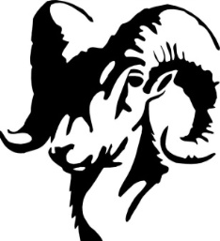

**School Board Principal’s Report January 2025**

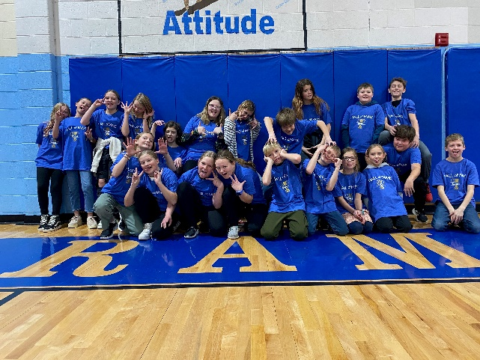

**2024 Ramsay Hall of Fame Competitors**

**Enrollment as of January 8, 2025**

Kindergarten: 16

First Grade: 19

Second Grade: 20

Third Grade: 20

Fourth Grade: 26

Fifth Grade: 12

Sixth Grade: 25

Seventh Grade: 7

Eighth Grade: 12

Resource: 1

**TOTAL: 158**

**UPDATES:**

* Ramsay Park / Butte Parks and Rec
* CRISS Training
* SPED Teacher
* Boys’ Basketball
* Girls’ Basketball
* Bus Driver Position/Bus Route
* Mrs. Earhardt – Classroom Aide
* Hall of Fame (4th - 6th) – December 12th! Plaque/shirts
* Hayride – December 16th!
* Christmas Program 6:30 PM– December 18th!
* Teacher/Staff Breakfast – December 19th!

**COMING EVENTS:**

* Downhill Skiing – January 16th
* Cross Country Skiing
* SBAC Testing (2nd Round)
* Resident Artist
* Science Fair – February (Missoula – March)
* Howard – Plaque
* Music Teacher – 4th Quarter
* Replacement of the Mods/Contractors/Contractor Guidelines
* Next meeting: February 11th?