**RAMSAY SCHOOL**

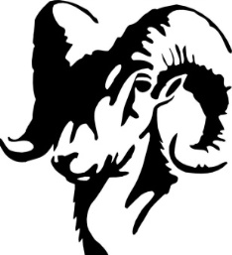

**School Board Principal’s Report November 2024**

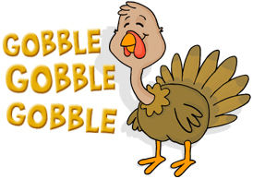

**Enrollment as of November 13, 2024**

Kindergarten: 16

First Grade: 19

Second Grade: 20

Third Grade: 21

Fourth Grade: 25

Fifth Grade: 14

Sixth Grade: 23

Seventh Grade: 6

Eighth Grade: 12

Resource: 1

**TOTAL: 157**

**UPDATES:**

* Ramsay Park / Butte Parks and Rec
* CRISS Training
* Earthquake Drill – November 13th
* State Teacher Training – October 17th - 18th.
* Halloween Parade!
* 2024 SBAC Testing
* Engineer Position
* SPED Teacher
* Art/Shop

**COMING EVENTS:**

* Boys’ Basketball
* Ranger in the Classroom (3rd - 8th) – December 4th
* Animal Wonders
* Hall of Fame (4th - 6th) – December 12th!
* Hayride – December 16th!
* Christmas Program – December 18th!
* Teacher/Staff Breakfast – December 19th!
* Bus Driver Position
* Music Teacher
* Replacement of the Mods/Contractors/Contractor Guidelines
* Next meeting: December 11th?