**RAMSAY SCHOOL**



**School Board Principal’s Report June 2024**

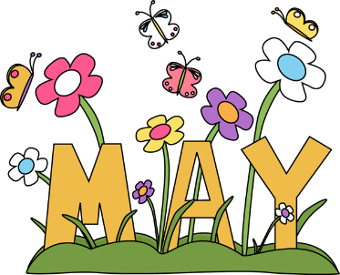

**Enrollment as of May 22, 2024**

Kindergarten: 19

First Grade: 18

Second Grade: 20

Third Grade: 22

Fourth Grade: 14

Fifth Grade: 23

Sixth Grade: 21

Seventh Grade: 11

Eighth Grade: 8

Resource: 2

**TOTAL: 158**

**UPDATES:**

* Teacher/Staff Appreciation Week!!! Thank you, PIE!!!
* Ramsay Park / Butte Parks and Rec
* Contractor/Dayspring/Repairs/Insurance
* Kitchen floor update
* 2024-2025 School Calendar - Amendment
* 4th Quarter midterm on May 2nd!
* SPED Teaching Position Recommendation
* CRISS Training
* Draw the Line/Respect the Line for 6th- 8th grade will start on April 29th.
* The 5th grade field trip to the Moiese Bison Range will take place on April 11th.
* 8th Grade Yellowstone Field Trip – May 14th – 16th!! Have fun!!
* 2nd Grade Field Trip – Museum of the Rockies on May 20th!
* 1st Grade Field Trip – Marley’s Paint Pots on May 22nd!

**COMING EVENTS:**

* The City Track meet has been rescheduled for May 28th. Thank you, Coach Courtney Barnett!!
* Fieldtrips
* PIE Color War!! – June 3rd
* 8th Grade Graduation – June 5th
* Last day of school – June 12th
* McKinstry proposals
* Replacement of the Mods/Contractors/Contractor Guidelines
* Engineer Position
* Next meeting: June 12th?