**RAMSAY SCHOOL**



**School Board Principal’s Report June 2024**

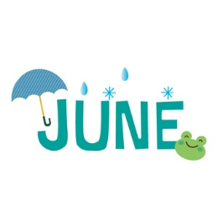

**Enrollment as of June 19, 2024**

Kindergarten: 19

First Grade: 18

Second Grade: 20

Third Grade: 22

Fourth Grade: 14

Fifth Grade: 23

Sixth Grade: 21

Seventh Grade: 11

Eighth Grade: 8

Resource: 2

**TOTAL: 158**

**UPDATES:**

* 8th grade graduation June 5th!
* Last Day of School and Ramsay Fun Day on June 12th!!! Thank you, PIE!!!
* Ramsay Park / Butte Parks and Rec
* Contractor/Dayspring/Repairs/Insurance
* 2024-2025 School Calendar - Amendment
* CRISS Training
* 2024 orders/supplies

**COMING EVENTS:**

* Shop/Art/Music
* McKinstry proposals
* Replacement of the Mods/Contractors/Contractor Guidelines
* Engineer Position
* Next meeting: July 10th?