RAMSAY SCHOOL
School Board Principal’s Report April 2024
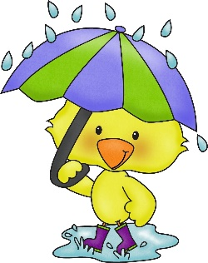
Enrollment as of April 10, 2024
Kindergarten: 19
First Grade: 18
Second Grade: 19
Third Grade: 22
Fourth Grade: 13
Fifth Grade: 23
Sixth Grade: 21
Seventh Grade: 11
Eighth Grade: 8
Resource: 2

TOTAL: 156

UPDATES:
- Kindergarten Registration

- School Report Cards

- Ceiling tiles

- Ramsay Park / Butte Parks and Rec

- Contractor/Dayspring/Repairs/Insurance

- Kitchen floor update

- 2024-2025 School Calendar

- 4th Quarter began on April 8th!

- The Downhill Skiing Program concluded on March 13th! Thank you, Biggers Transport!

- The 5th and 6th Girls’ Basketball season had come to an end.

- The last make-up day was completed on April 5th.

- Academic Olympics was held in Bozeman on Tuesday, March 12th!

- Elementary Teaching Position (3rd Grade) Recommendation

COMING EVENTS:

- Draw the Line/Respect the Line for 6th- 8th grade will start on April 29th.

- The 5th grade field trip to the Moiese Bison Range will take place on April 11th.

- Track practice has begun! Thank you, Coach Courtney Barnett!!

- McKinstry proposals

- Replacement of the Mods/Contractors/Contractor Guidelines

- Engineer Position

- Special Education Position

- Next meeting: May 8th?

