RAMSAY SCHOOL
School Board Principal’s Report December 2023
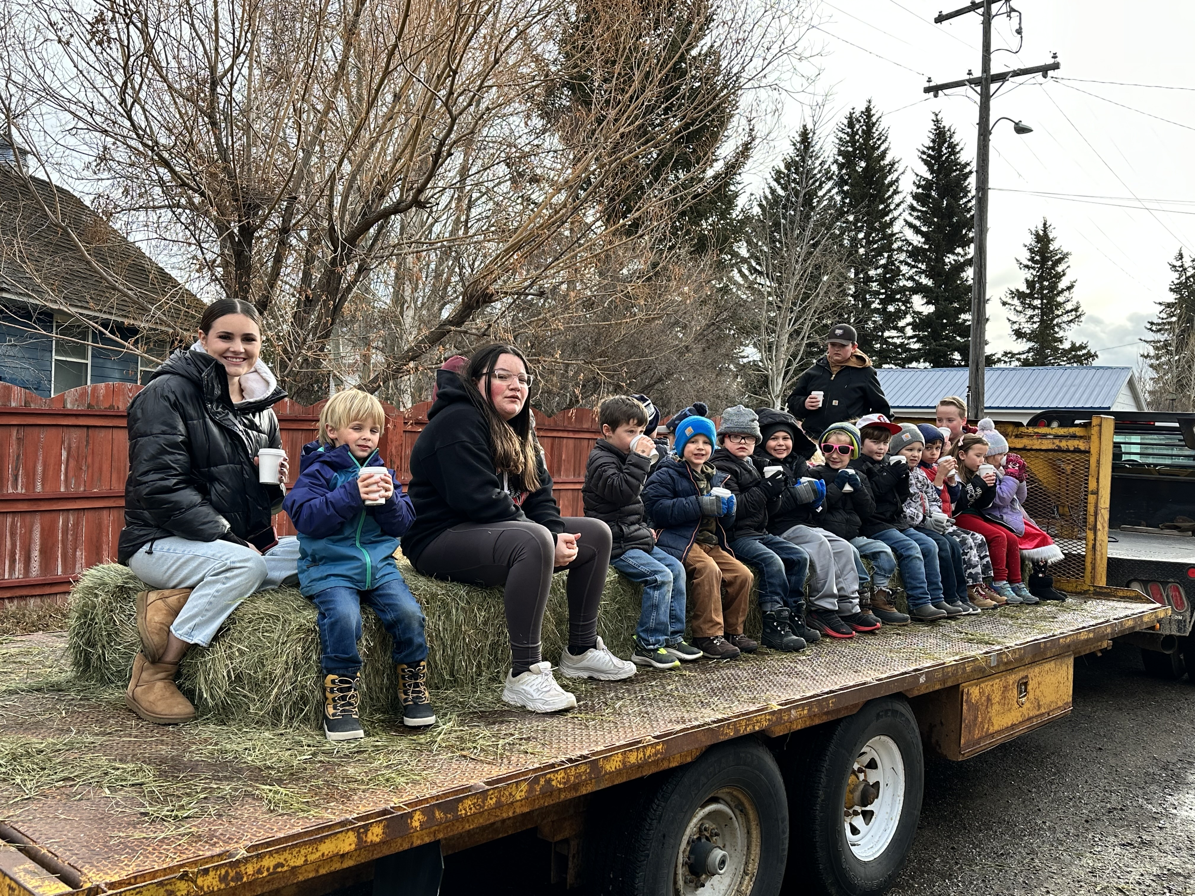
Kindergarten and 7th Grade on the Hayride!!!
Enrollment as of December 13, 2023
Kindergarten: 19
First Grade: 18
Second Grade: 21
Third Grade: 23
Fourth Grade: 14
Fifth Grade: 24
Sixth Grade: 23
Seventh Grade: 11
Eighth Grade: 9
Resource: 2

TOTAL: 164

UPDATES:
- Ramsay Park / Butte Parks and Rec

- Electrical/Water issues - Insurance Claim

- All board members must complete CRISS Training.

- The 5th/6th Boys Basketball season has begun! starting!

- The Ramsay Hayride was held on December 7th. Thank you, Ueland Family!!

- 2nd Quarter Title scores

COMING EVENTS:

- Replacement of the Mods/Contractors/Contractor Guidelines

- All staff CRP/First Aid will be held on December 14th.

- Staff Breakfast will be held on December 19th.

- Next meeting: January 10th?

