RAMSAY SCHOOL
School Board Principal’s Report September 2023

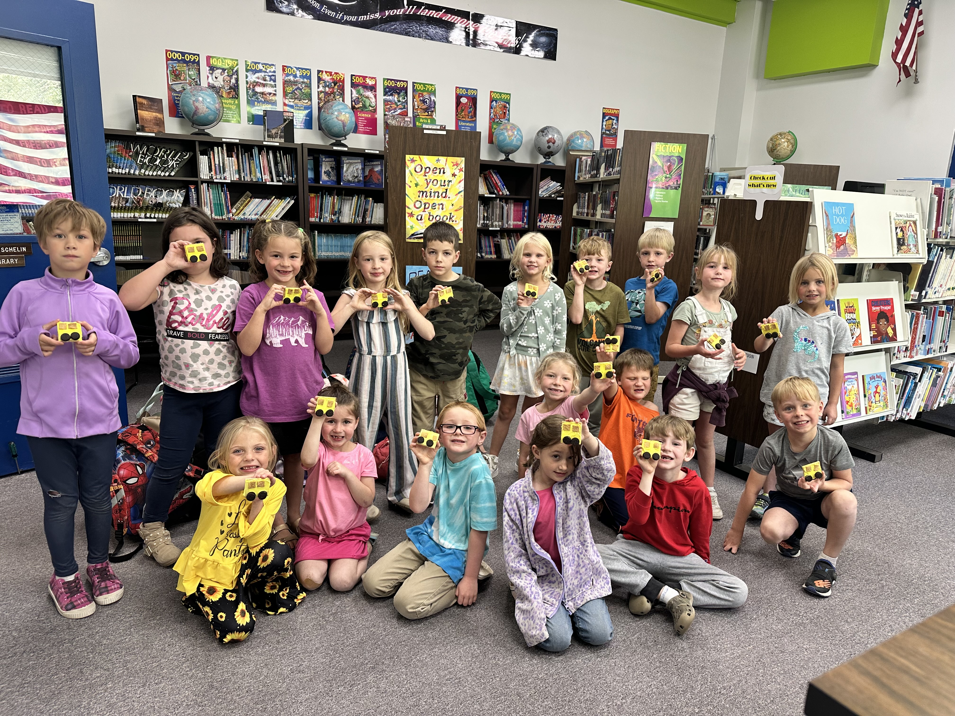
Ramsay First Grade in Library!!

Enrollment as of September 21, 2023
Kindergarten: 19
First Grade: 19
Second Grade: 21
Third Grade: 23
Fourth Grade: 14
Fifth Grade: 24
Sixth Grade: 24
Seventh Grade: 11
Eighth Grade: 9
Resource: 2

TOTAL: 166

UPDATES:
- McKinstry Engineering Firm – Butte Parks and Rec

- Electrical/Water issues - Insurance Claim

- All board members must complete CRISS Training.

- PIR days and first few weeks of school have been excellent!

- Ramsay Swimming Program started on September 11th!

- City Cross-Country Meet!

- Open Bus Driver position has been filled.

- All employee background information has been received besides Kindergarten (No Concerns)

- Permanent Substitute position

- Out-of-school suspension

COMING EVENTS:
- Memorial Bench?

- 5th and 6th grade volleyball seasons have begun!

- Fire Safety Class (K-5) – October 17th.

- School Pictures on October 18th.

- Replacement of the Mods/Contractors/Contractor Guidelines

- Next meeting: October 18th?

