RAMSAY SCHOOL
School Board Principal’s Report November 2023

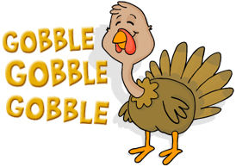
Enrollment as of November 13, 2023
Kindergarten: 19
First Grade: 18
Second Grade: 21
Third Grade: 23
Fourth Grade: 14
Fifth Grade: 24
Sixth Grade: 23
Seventh Grade: 11
Eighth Grade: 8
Resource: 2

TOTAL: 163

UPDATES:
- Ramsay Park / Butte Parks and Rec

- Electrical/Water issues - Insurance Claim

- All board members must complete CRISS Training.

- 5th and 6th grade girls’ volleyball are preparing for end-of-the-year tournaments! Good luck ladies!!

- The 5th/6th Boys Basketball season is starting!

- The Ramsay Hay Ride will be held on December 7th. Thank you, Ueland Family!!

- All staff CRP/First Aid will be held on December 14th.

- Out-of-school suspension

COMING EVENTS:

- Replacement of the Mods/Contractors/Contractor Guidelines

- Next meeting: December 13th?

