**RAMSAY SCHOOL**



**School Board Principal’s Report June 2023**

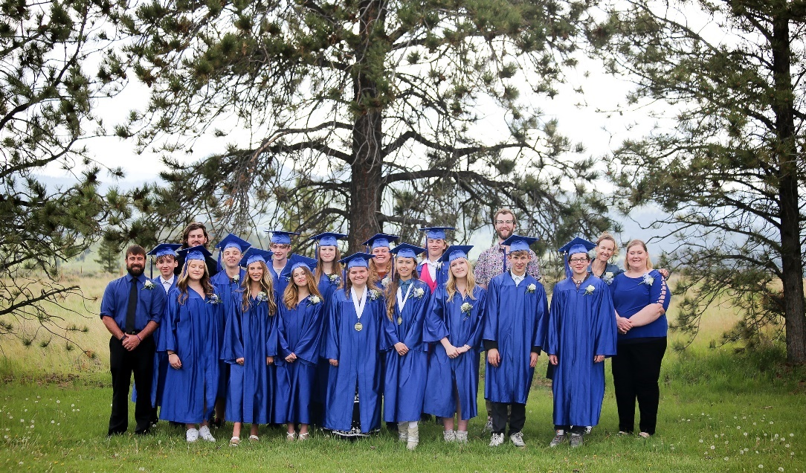

**2023 Ramsay School 8th Grade Graduating Class!!**

**Enrollment as of June 6, 2023**

Kindergarten: 20

First Grade: 21

Second Grade: 23

Third Grade: 15

Fourth Grade: 22

Fifth Grade: 23

Sixth Grade: 19

Seventh Grade: 9

Eighth Grade: 15

Resource: 3

**TOTAL: 170**

**UPDATES:**

* Emergency Day – May 29th
* Electrical/Water issues - Insurance Claim
* 8th Grade graduation was held on May 31st!
* The last day of school was June 6th! PIE hosted a great field day!! Thank you, PIE!! 😊
* Teacher/Staff PIR Day – June 7th.
* The gym floor has been repaired and re-waxed.
* All the new buses have been delivered.
* Currently completing staff/teacher orders for 2023-2024
* Waiting on gym teacher’s background check results
* McKinstry Engineering Firm – Board visit in July
* Ramsay Park
* All board members must complete CRISS Training.
* Ramsay School received a state ranking of “Universal” in SBAC Testing results for the 2021-2022 school year!! High percentage of proficient and near proficient in Math and ELA for grades 3-8.
* SBAC Testing has been completed for the year for 3rd-8th. The SBAC Breakdown Analysis has been requested for 2021-2022 school year scores.
* 8th Grade Graduation will take place on March 31st.
* Security System replacement

**COMING EVENTS:**

* Math Curriculum/PD
* SPED/Counselor….0.425 FTE
* Replacement of the Mods/Contractors/Contractor Guidelines
* Next meeting: July 19th?