RAMSAY SCHOOL
School Board Principal’s Report August 2023

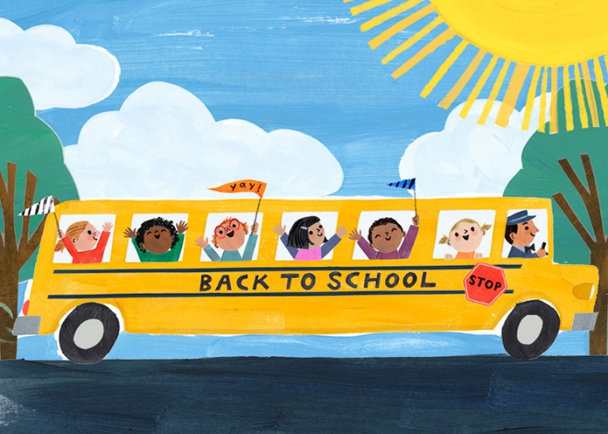

Enrollment as of August 16, 2023
Kindergarten: 19
First Grade: 17
Second Grade: 21
Third Grade: 24
Fourth Grade: 13
Fifth Grade: 24
Sixth Grade: 24
Seventh Grade: 12
Eighth Grade: 11
Resource: 2

TOTAL: 167

UPDATES:
- McKinstry Engineering Firm – Butte Parks and Rec

- Electrical/Water issues - Insurance Claim

- Permanent Substitute position

- Waiting on gym teacher’s background check results

- All board members must complete CRISS Training.

- The Payne West Ramsay Inspection has been completed.

- Ramsay Swimming Program will start September 11th!

COMING EVENTS:
- Open Bus Driver position

- Teacher/Staff PD – August 28th and 29th - Math Curriculum/PD

- The first day of school is August 30th!!

- Cross Country practice will start on August 30th!! Thank you, Coach Barnett!

- SPED/Counselor….0.425 FTE

- Replacement of the Mods/Contractors/Contractor Guidelines

- Next meeting: September 20th?

